UNIVERSITY OF JAMMU
BHADERWAH CAMPUS


BACHELOR OF COMPUTER APPLICATION
(BCA-4th SEMESTER 2024-28)
PRACTICAL FILE
PYTHON PROGRAMMING

SUBMITTED BY: SUBMITTED TO:
Damit Singh Mr. Abhay Khajuria
413040013 (Astt. Professor)
Dept. Of CS and IT
ACKNOWLEDGEMENT

I would like to express my gratitude to all those people who helped me to complete this practical file. I want to thank Department of computer science and IT for providing me all the tools and resources for the completion of my practical file.
I have further more to thank our respected teacher Mr. Abhay Khajuria who encouraged me to move ahead and complete my work in time.
At last, I want to thank my classmates and friends for their help, support, interest and valuable hints. I want to thank once again all the above mentioned persons for their time and help.
Thank you.

Damit Singh
BCA 4th Semester
413040013

CERTIFICATE

This is to certify that Damit Singh student of BCA-4th semester bearing university Roll no. 413040013 has completed the required number of practicals of Python Programming under the guidance of class teacher Mr. Abhay Khajuria from the Department of Computer science and IT, Bhaderwah campus, University of Jammu.

Signature. Signature.
(I/C course coordinator) (Practical I/C)
Index
No. | Contents | Remarks
1 | WAP to check whether a number is even or odd.
2 | WAP to check whether a given number is prime or not.
3 | WAP to find the largest among three numbers.
4 | WAP to check whether a given year is a leap year or not.
5 | WAP to calculate the factorial of a given number.
6 | WAP to generate the Fibonacci sequence up to n terms.
7 | WAP to reverse a given number without using built-in function.
8 | WAP to check whether a given number is an Armstrong number.
9 | WAP to check whether a given string is a palindrome or not.
10 | WAP to count the number of vowels and consonants in a given string.
11 | WAP to count the frequency of each character in a string.
12 | WAP to reverse a given string.
13 | WAP to remove duplicate characters from a given string.
14 | WAP to sort the character of a string in alphabetical order.
15 | WAP to find the longest word in a given sentence.
16 | WAP to find the first occurrence of a substring in a string.
17 | WAP to find the sum of all elements in a given list.
18 | WAP to find the largest and smallest elements in a given list.
19 | WAP to remove duplicate elements from a list.
20 | WAP to merge two list into one.
21 | WAP to sort a list in ascending and descending order.
22 | WAP to find common elements between two strings.
23 | WAP to check whether a list is sorted or not.
24 | WAP to rotate elements of a list by n positions.
25 | WAP to find the second largest number in a list.
26 | WAP to count the frequency of words in a given sentence using a dictionary.
27 | WAP to check whether a key exists in a dictionary.
28 | WAP to sort a dictionary by its values.
29 | WAP to convert two lists into a dictionary (keys and values).
30 | WAP to perform union, intersection and difference operation on sets.

WAP to check whether a given number is even or odd.
def find_even_odd(number):
if number & 1 == 0:
return "Even Number"
return "Odd Number"

user_val = int(input("Provide a number: "))
print(f"The number {user_val} is an {find_even_odd(user_val)}")

Output:-

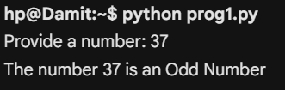

WAP to check whether a given number is prime or not.
def check_prime_status(val):
if val < 2:
return False
for divisor in range(2, int(val ** 0.5) + 1):
if val % divisor == 0:
return False
return True

num_input = int(input("Enter number to verify: "))
if check_prime_status(num_input):
print(f"{num_input} is a Prime Number.")
else:
print(f"{num_input} is NOT a Prime Number.")

Output:-

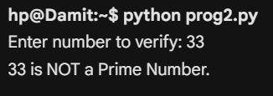

WAP to find the largest among three numbers.
x = int(input("Enter first integer: "))
y = int(input("Enter second integer: "))
z = int(input("Enter third integer: "))

max_val = x
if y > max_val:
max_val = y
if z > max_val:
max_val = z

print(f"The maximum value is: {max_val}")

Output:-

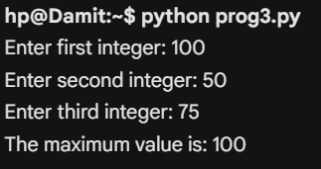

WAP to check whether a given year is a leap year or not.
input_year = int(input("Enter a year: "))
if input_year % 400 == 0 or (input_year % 4 == 0 and input_year % 100 != 0):
print("Result: Leap Year")
else:
print("Result: Normal Year")

Output:-



WAP to calculate the factorial of a given number.
n = int(input("Enter a positive number: "))
factorial_result = 1
current = n

while current > 0:
factorial_result *= current
current -= 1

print(f"Factorial = {factorial_result}")

Output:-

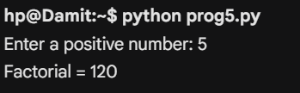

WAP to generate the Fibonacci sequence up to n terms.
limit = int(input("Enter number of terms required: "))
series = [0, 1]

if limit <= 0:
print("Please enter a positive integer.")
elif limit == 1:
print("Series:", [0])
else:
while len(series) < limit:
next_val = series[-1] + series[-2]
series.append(next_val)
print("Series:", series)

Output:-

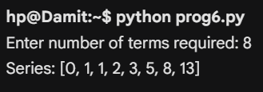

WAP to reverse a given number without using built-in function.
original_number = int(input("Type a number: "))
reversed_result = 0

while original_number != 0:
digit = original_number % 10
reversed_result = (reversed_result * 10) + digit
original_number //= 10

print(f"Flipped Number: {reversed_result}")

Output:-

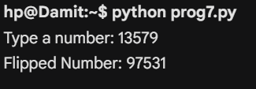

WAP to check whether a given number is an Armstrong number.
number_string = input("Enter a number to check: ")
length = len(number_string)
calculated_sum = 0

for char in number_string:
calculated_sum += int(char) ** length

if str(calculated_sum) == number_string:
print("Validation: True (It is an Armstrong number)")
else:
print("Validation: False")

Output:-

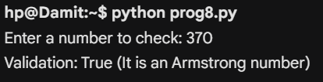

WAP to check whether a given string is a palindrome or not.
user_str = input("Type a word: ")
is_palindrome = True

for i in range(len(user_str) // 2):
if user_str[i] != user_str[-(i + 1)]:
is_palindrome = False
break

if is_palindrome:
print("The word is a palindrome.")
else:
print("The word is not a palindrome.")

Output:-

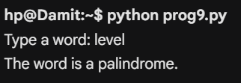
WAP to count the number of vowels and consonants in a given string.
sentence = input("Type a sentence: ").replace(" ", "").lower()
vowels_list = {'a', 'e', 'i', 'o', 'u'}
v_count = 0
c_count = 0

for alphabet in sentence:
if alphabet.isalpha():
if alphabet in vowels_list:
v_count += 1
else:
c_count += 1

print(f"Total Vowels = {v_count}")
print(f"Total Consonants = {c_count}")

Output:-

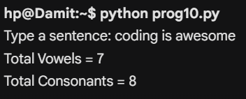

WAP to count the frequency of each character in a string.
target_string = input("Provide text: ")
character_dict = {}

for letter in target_string:
if letter in character_dict:
character_dict[letter] += 1
else:
character_dict[letter] = 1

print("Frequencies:", character_dict)

Output:-

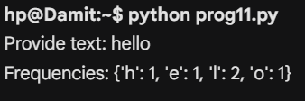

WAP to reverse a given string.
string_to_reverse = input("String input: ")
backward_str = ""

for char in string_to_reverse:
backward_str = char + backward_str

print(f"Reversed string format: {backward_str}")

Output:-

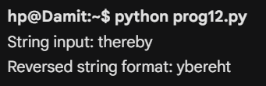

WAP to remove duplicate characters from a given string.
input_word = input("Enter a string: ")
no_duplicates = "".join(dict.fromkeys(input_word))
print(f"Cleaned string: {no_duplicates}")

Output:-


WAP to sort the character of a string in alphabetical order.
jumbled_string = input("Enter jumbled string: ")
character_list = list(jumbled_string)
character_list.sort()
print("Alphabetical order:", "".join(character_list))

Output:-


WAP to find the longest word in a given sentence.
text_line = input("Provide a full sentence: ")
word_array = text_line.split()
max_word = ""

for item in word_array:
if len(item) > len(max_word):
max_word = item

print(f"The longest word extracted: {max_word}")

Output:-

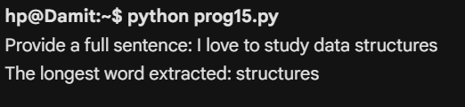

WAP to find the first occurrence of a substring in a string.
base_text = input("Enter main text: ")
search_term = input("Enter substring: ")

try:
loc = base_text.index(search_term)
print(f"Substring starts at index number: {loc}")
except ValueError:
print("Substring does not exist in the text.")

Output:-

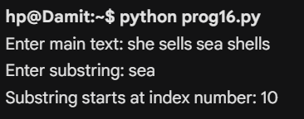

WAP to find the sum of all elements in a given list.
size = int(input("Number of values in list: "))
collection = []
total_sum = 0

for i in range(size):
val = int(input(f"Value [{i}]: "))
collection.append(val)
total_sum += val

print(f"List sum evaluates to: {total_sum}")

Output:-

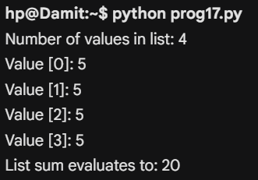

WAP to find the largest and smallest elements in a given list.
num_elements = int(input("Enter count: "))
data_list = []

for _ in range(num_elements):
data_list.append(int(input("Enter number: ")))

max_val = data_list[0]
min_val = data_list[0]

for number in data_list:
if number > max_val:
max_val = number
if number < min_val:
min_val = number

print(f"Maximum = {max_val} | Minimum = {min_val}")

Output:-

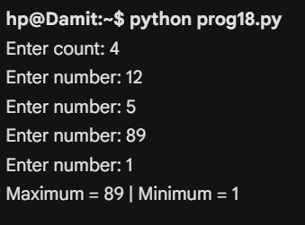
WAP to remove duplicate elements from a list.
raw_entries = input("Provide space-separated values: ").split()
filtered_entries = []

[filtered_entries.append(x) for x in raw_entries if x not in filtered_entries]

print(f"List without duplicates: {filtered_entries}")

Output:-

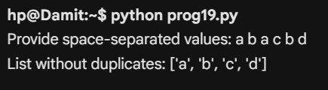

WAP to merge two list into one.
first_list = input("Input list A: ").split()
second_list = input("Input list B: ").split()

first_list.extend(second_list)
print("Final combined list:", first_list)

Output:-

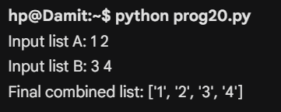

WAP to sort a list in ascending and descending order.
values = [int(v) for v in input("Enter integers to sort: ").split()]

values.sort()
print(f"Ascending order: {values}")

values.sort(reverse=True)
print(f"Descending order: {values}")

Output:-

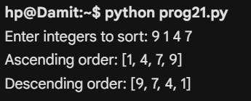
WAP to find common elements between two strings.
s1 = input("Type string one: ")
s2 = input("Type string two: ")

common_chars = "".join(set([char for char in s1 if char in s2]))
print(f"Intersecting characters: {common_chars}")

Output:-

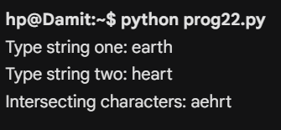
WAP to check whether a list is sorted or not.
num_list = [int(x) for x in input("Enter numbers: ").split()]

is_asc = all(num_list[i] <= num_list[i + 1] for i in range(len(num_list) - 1))
is_desc = all(num_list[i] >= num_list[i + 1] for i in range(len(num_list) - 1))

if is_asc or is_desc:
print("The list is currently sorted.")
else:
print("The list is unsorted.")

Output:-

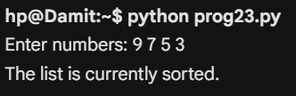

WAP to rotate elements of a list by n positions.
data_arr = input("Enter items: ").split()
rotations = int(input("How many steps to rotate right? "))

rotations = rotations % len(data_arr)
shifted_arr = data_arr[-rotations:] + data_arr[:-rotations]
print(f"After rotation: {shifted_arr}")

Output:-

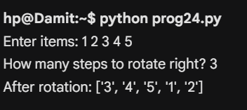

WAP to find the second largest number in a list.
number_series = [float(x) for x in input("Enter numbers: ").split()]

if len(set(number_series)) < 2:
print("Not enough unique numbers.")
else:
number_series.remove(max(number_series))
print(f"The second largest element is: {max(number_series)}")

Output:-

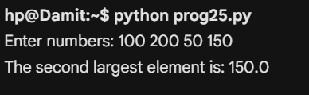

WAP to count the frequency of words in a given sentence using a dictionary.
phrase = input("Enter a sentence: ").lower().split()
word_tracker = {}

for w in phrase:
if w in word_tracker:
word_tracker[w] += 1
else:
word_tracker[w] = 1

print("Word Dictionary Mapping:", word_tracker)

Output:-

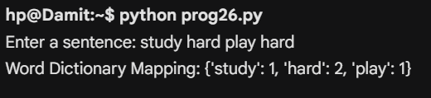
WAP to check whether a key exists in a dictionary.
inventory = {"apples": 10, "bananas": 5, "oranges": 8}
item_to_check = input("Enter item to search for: ")

if item_to_check in inventory.keys():
print(f"Found it! {item_to_check} is in the inventory.")
else:
print(f"Missing! {item_to_check} is not listed.")

Output:-



WAP to sort a dictionary by its values.
raw_dict = {"Math": 85, "Science": 92, "English": 78}
sorted_by_val = {k: v for k, v in sorted(raw_dict.items(), key=lambda item: item[1])}
print(f"Ascending Value Sort: {sorted_by_val}")

Output:-

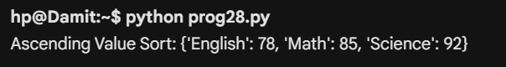
WAP to convert two lists into a dictionary (keys and values).
attr_list = input("Enter attributes (keys): ").split()
val_list = input("Enter details (values): ").split()

constructed_dict = {}
for idx in range(min(len(attr_list), len(val_list))):
constructed_dict[attr_list[idx]] = val_list[idx]

print("Created Dictionary:", constructed_dict)

Output:-

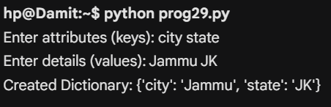
WAP to perform union, intersection and difference operation on sets.
set_x = {10, 20, 30, 40}
set_y = {30, 40, 50, 60}

print(f"Set X: {set_x} | Set Y: {set_y}")
print(f"Union (X | Y): {set_x.union(set_y)}")
print(f"Intersection (X & Y): {set_x.intersection(set_y)}")
print(f"Difference (X - Y): {set_x.difference(set_y)}")

Output:-

